Kartik Diwan 190905246 CSE B

Operating System Lab Session 2

SE)

Code:

#include <unistd.h>
#include <stdio.h>
#include <dirent.h>
#include <string.h>
#include <sys/stat.h>
#include <stdlib.h>

void printdir(char *dir, int depth)
{
DIR *dp;
struct dirent *entry;
if((dp = opendir(dir)) == NULL)
{
fprintf(stderr,"Cannot open directory: %s\n",dir);
exit(1);
}
while((entry = readdir(dp)) != NULL)
{
printf("%s\n",entry->d_name);
}
closedir(dp);
}
void main()
{
printf("Directory scan of /home/Student\n");
printdir("/home/Student",0);
printf("Done.\n");
exit(0);
}

Output:

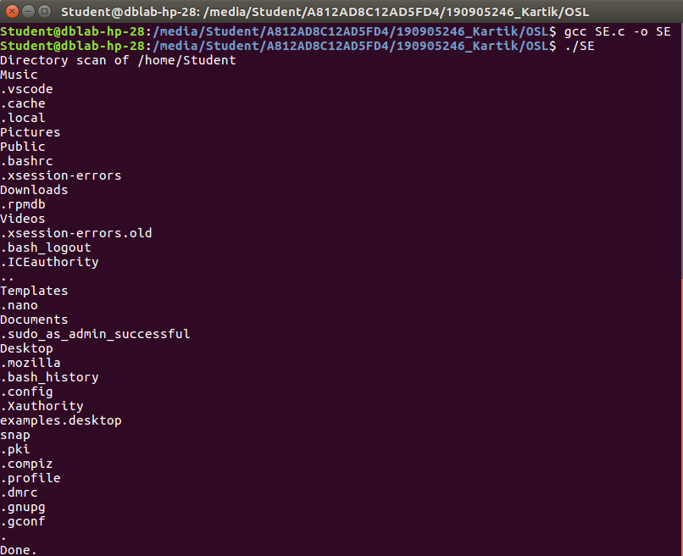

Q1)

Code:

#include <unistd.h>
#include <stdlib.h>
#include <stdio.h>
#include <sys/stat.h>
#include <sys/types.h>
#include <dirent.h>

void main()
{
DIR * dp;
struct dirent * entry;
struct stat statbuf;
if(!(dp = opendir(".")))
{
printf("Can't open directory \n");
exit(1);
}
chdir(".");
printf("\n");
while(entry = readdir(dp))
{
lstat(entry->d_name, &statbuf);
printf("%s\t",entry->d_name);
if(!S_ISDIR(statbuf.st_mode))
{
printf((S_ISDIR(statbuf.st_mode)) ? "d" : "-");
printf((statbuf.st_mode & S_IRUSR) ? "r" : "-");
printf((statbuf.st_mode & S_IWUSR) ? "w" : "-");
printf((statbuf.st_mode & S_IXUSR) ? "x" : "-");
printf((statbuf.st_mode & S_IRGRP) ? "r" : "-");
printf((statbuf.st_mode & S_IWGRP) ? "w" : "-");
printf((statbuf.st_mode & S_IXGRP) ? "x" : "-");
printf((statbuf.st_mode & S_IROTH) ? "r" : "-");
printf((statbuf.st_mode & S_IWOTH) ? "w" : "-");
printf((statbuf.st_mode & S_IXOTH) ? "x" : "-");
printf("\n");
}
}
}

Output:

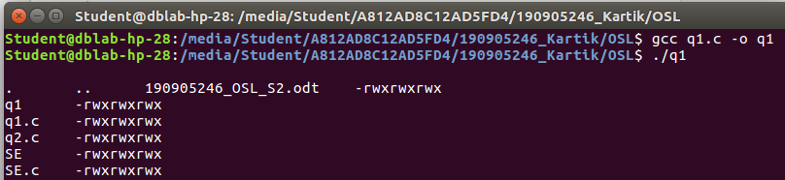
Q2)

Code:

#include <stdio.h>
#include <unistd.h>
#include <dirent.h>
#include <string.h>
#include <sys/stat.h>
#include <stdlib.h>

void printdir(char *dir, int depth)
{
DIR *dp;
struct dirent* entry;
struct stat statbuf;
if((dp=opendir(dir))==NULL)
{
fprintf(stderr, "Can't open directory: %s\n",dir);
return;
}
chdir(dir);
while((entry=readdir(dp)) != NULL)
{
lstat(entry->d_name,&statbuf);
if(S_ISDIR(statbuf.st_mode))
{
if(strcmp(".",entry->d_name)==0 || strcmp("..",entry->d_name)==0)
continue;
printf("%*s%s\n",depth,"",entry->d_name);
printdir(entry->d_name,depth+4);
}
else
printf("%*s%s\n",depth,"",entry->d_name);

}
chdir("..");
closedir(dp);
}

void main()
{
char name[100];
printf("Enter directory to print:\n");
scanf("%s",name);
printdir(name,0);
printf("Done!\n");
}

Output:

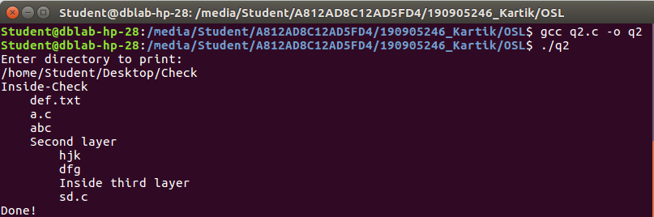
Q3)
apt list --installed

Q4)
rpm -qa

